Respiratory Therapist Work

Student’s Name
Institutional Affiliation
Date

- Whistling sound in a bubble humidifier? How would you troubleshoot it?
Medical devices known as bubble humidifiers are used to humidify supplementary oxygen. Underwater gas is diffused into tiny bubbles by the machines (Singer et al., 2015). The gas is directed below the water's surface, where the bubbles help prevent evaporation and provide humidity. The higher the flow, the higher the humidity, and the lower the flow, the lower the humidity. When there is an obstruction in the delivery tube, the patient's bubble humidifier emits a whistling sound, according to Singer et al. (2015). When the pressure in the reservoir container reaches the valve's threshold pressure, the bubble humidifier sounds like a relief valve. According to Tong & Gonzalez (2020), noise faults are typically caused by a faulty fan motor, insufficient lubrication of the drive mechanism, and a blocked drain system. Before troubleshooting, make sure the humidifier is unplugged. The following are some options for dealing with a noisy humidifier: The fan has to be lubricated. Because of the device's mechanical flaws, the humidifier is compelled to create noises. As a result, lubrication is required right away.
To grease the fan motor, lift the sticker on the rear. Due to loose components, the lubricator will occasionally emit noises and continue to vibrate. If there are any loose screws, they should be tightened in this situation (Singer et al. 2015). Defective water valves or clogged fan blades can also cause loud noises. Cleaning and proper maintenance, such as repair, are required to solve this.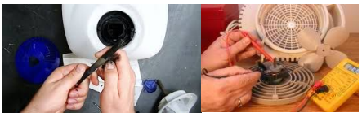

- How is the proper function of a humidifier checked?
There are several ways to determine whether or not a humidifier is functioning correctly. When you switch it on, you should hear an audible click followed by a humidifier fun sound (Tong & Gonzalez 2020). Running water should also be seen coming out of the humidifier's drain tube at the bottom. A properly working humidifier will maintain a comfortable moisture level for the patient's comfort during therapy and medical operations. The flow meter is set, and the oxygen supply is steady in a well-functioning humidifier.
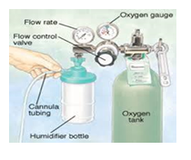
- When providing a handheld nebulizer, what sound indicates that the solution has been nebulized?
To improve the medication's administration, the patient must breathe in and out for around 1-3 seconds. When the medicine is no longer present, and a mist is visible, the treatment is completed. The majority of the solution has been nebulized, as indicated by a spattering sound (Singer et al., 2015). As a result, the therapy is completed, which could take up to 20 minutes. The device is simple to operate, safe, and gives about 100% body humidity.
- What can cause an LVN (large volume nebulizer) not to be mist enough? Provide three possible causes.
Dirt or residue in the nebulizer may cause it to mist insufficiently. Replacement accessories can efficiently address such issues (Tong & Gonzalez 2020). If the nebulizer is broken, it may not mist sufficiently. In this circumstance, it is critical to call the doctor and request a replacement. In addition, if the patient is wearing the incorrect accessories. It is simple to mix up chambers, masks, and other equipment when the patient is sick. Because not all machines are compatible with each other, the mismatch might lead to the poor output.
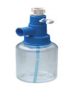
- What can cause the FiO2 to change during LVN therapy? How can it be fixed?
Because the oxygen flow rate changes, the FiO2 is not constant. The device's flow interferes with the inspiratory flow, resulting in fluctuating FiO2 levels (Moody & Ari 2020). It is critical to give fixed oxygen concentrations based on the client's inspiratory demands to correct this. It can also be resolved by acquiring the appropriate oxygen delivery system.

- During Incentive Spirometry, what common troubleshooting problems may you find?
In general, there are very few issues that can arise when using Incentive Spirometry. However, a small number of occurrences of collapsed lungs have been linked to the use of Incentive Spirometry, particularly in emphysema patients (Harris et al., 2016). Excessive use of the gadget could result in lung damage or even death.
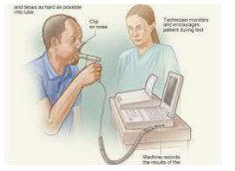

Reference
Harris et al. (2016). Development of a novel device for monitoring incentive spirometry
performance. Sains Malaysiana, 45(7), 1121-1129.
Moody & Ari (2020). Quantifying continuous nebulization via high flow nasal cannula and large
volume nebulizer in a pediatric model. Pediatric Pulmonology, 55(10), 2596-2602.
Singer et al. (2015). Understanding the benefits and harms of oxygen therapy. Intensive care
medicine, 41(6), 1118-1121.
Tong & Gonzalez (2020). Respiratory Emergencies. Veterinary Clinics: Small Animal Practice,
50(6), 1237-1259.

